

Southern California Edison
CS Re-Platform Project

CIM-CS-12 Manage Customer Interactions
Customer Service- CIM
Business Process Design
Version 2.2

Table of Contents
1 Business Process Overview 5
1.1 Current Pain Points for Southern California Edison 5
1.2 Responsible Parties 5
1.3 Document Control 6
1.4 Terminology 6
2 Business Process Design 8
2.1 Manage Customer Interaction Details 8
2.1.1 Activities Properties 10
2.1.2 BP Contact Properties 10
2.1.3 Activity Attachments 11
2.1.4 Activity Search 12
2.1.5 Follow-up 12
2.2 Process / Performance Improvement 13
2.3 Prerequisites and Inputs 13
2.4 General Assumptions 13
2.5 Business Process Hierarchy 13
2.6 Process Flows 14
2.6.1 Manual Creation 14
2.7 3rd Party and SCE Legacy System Integrations 15
2.8 Data Elements 16
2.8.1 BP Contacts Data Elements 16
2.9 Cloud for Customer (C4C) Integration 16
2.9.1 Processes 16
2.9.2 C4C Views 16
2.9.3 Activities 16
2.10 Exception Management Requirements 16
2.11 Process Risks and Mitigation 17
2.12 Key Performance Indicators 17
2.12.1 Key Metric Definition 17
3 Controls, Regulatory Rules, and Security 18
3.1 Security Considerations 18
3.2 Custom Program/Transaction Codes 18
3.3 Custom Table/Transaction Codes 18
3.4 Data Criticality and Cybersecurity Baseline Risks 19
4 Technical Considerations 21
4.1 RICEF-W Assessment 21
4.1.1 Reports 21
4.1.2 Interfaces 21
4.1.3 Conversion 22
4.1.4 Extension/Enhancements 22
4.1.5 Forms 22
4.1.6 Workflows 22
4.2 IDEX Considerations 22
4.3 Production System Cut-over Considerations 22
4.4 Other Considerations 22
5 Change Management 23
5.1 Change Impacts 23
6 Requirements 26

This page intentionally left blank

Business Process Overview
Manage Customer Interactions process will define how to create and display an Activity or a BP Contact within SCE’s SAP environment
An Activity can be recorded when a user or an SCE employee access details about a customer, regardless of whether or not the customer initiated the activity (e.g. SCE employee calls a customer) Activities will be captured manually by a Hybris C4C user upon client interaction. System executed processes (e.g. letters sent to the customer, dunning carried out, etc.) will create a BP contact automatically in S/4HANA.
The types of Activities/BP Contact that SCE has with its customers can be classified as:
- Customer interacting with a BCD representative
- Customer interacting with a CCC call center representative
- Customer interactions with SCE.com
- Customer interactions with IVR systems

Current Pain Points for Southern California Edison
- Notes aren’t searchable – Since the subject line is free text the user must scan through the notes to find the right one
- CSS Notes aren’t available in CRM, agents have to swivel between two systems

Responsible Parties
Contact | Contact Person
Southern California Edison Business Process Owner | Janet Covington
Southern California Edison Lead | Christine Evans
HCL Functional Lead | Adrianus Halim
Solution Architect | Pedro Ferreira da Costa
Front Office | Christine Evans
Subject Matter Experts | Christine Evans  Cari Young  Ernesto Valle  Pedro Costa
Key User Group | Customer Contact Center (CCC)  Business Customer Division (BCD)

Document Control
Version | Description of Change | Date | Author
1.1 | Creation of Initial Version | Dec. 13th, 2017 | Diego Lopes
1.2 | Updated with Process Flow and Enhancement List | Jan 7th, 2018 | Vasu Jasti
1.3 | Updated with Activity screen captures | Jan 14th, 2018 | Diego Lopes/Vasu Jasti
1.4 | Updated as per the first review | Jan 19th, 2018 | Diego Lopes
1.5 | HCL SA Review | Jan 24th, 2018 | Pedro Costa
1.6 | Updated as per the second review | Jan 29th, 2018 | Diego Lopes
1.7 | Updated as per business review | Feb 23rd, 2018 | Diego Lopes
1.8 | Updated with corrections | Feb 27th, 2018 | Diego Lopes
1.9 | Minor Updates | Feb 27th, 2018 | Adrianus Halim
2.0 | Updated as per review | Feb 27th, 2018 | Diego Lopes
2.1 | Updated as per review | Feb 28th, 2018 | Diego Lopes
2.2 | Minor updates | Mar 1st, 2018 | Diego Lopes

Terminology
Term/Acronym | Definition and SAP Equivalent (if applicable)
Activity | An Activity is defined as an event when an SCE employee or system interacts with the customer through a communication medium or performs an interaction associated with the customer’s account. Each activity type includes notes feature that allows you to add more information, as necessary.
APSE | Accelerated (or Axon) Project Support Environment
BDEX | SAP add-on functionality to support the processing of BPEM Cases
Billing Cycle | Is a group of contracts to be billed together via date-driven or regional criteria, it controls the billing cycle and is linked to the Meter Reading Unit. SAP equivalent term is the Portion.
Billing Document | A document that outlines the charges incurred for energy consumption for a specific contract. During the process of Billing, a billing document is generated for each contract on a contract account.
BMD | Business Master Data. The customer information which includes personal details, payment terms, dunning levels, billing rates and rate categories. The business master data objects are Business Partner, Business Agreement/Contract Account, and Contract.
BP | Business Partner
BPD | Business Process Design (or Document)
BPEM | Business Process Exception Management
BWR | Basic Work Request. SAP equivalent is BPEM.
BP Contact | This component logs and displays all BP contacts that are stored by this or by other components.
CA | Contract Account
Channel | Data object in SAP that holds the interval data. Intervals can be kwh, price, factor, etc. SAP equivalent is Profile.
Clarification | A list of payments that could not be processed and require additional work in order to be posted.
Connection Object | The link between installation and postal regional structure. Usually a building, but can also be a piece of property or another facility, such as a fountain or construction site. The connection object corresponds to the functional location in plant maintenance (PM).
CRB | SAP Customer Relationship & Billing system. This is what is being implemented with the CSRP program.
Customer | Any entity with a relationship with SCE. This term is usually used in reference to customers (both individuals and organizations) This can include employees and third-party suppliers (banks and payment partners). SAP Equivalent is Business Partner (BP)
EAM | SAP Enterprise Asset Management
ERP | SAP Enterprise Resource Planning
Hybris C4C | SAP Cloud for Customer Solution
IMG | SAP Implementation Guide - where configuration is performed
Level Pay Plans | SAP equivalent term is Budget Billing. Budget Billing allows customers to pay regular equal amounts over a yearly period.
S/4HANA | SAP ERP Central Component (SAP) - The core SAP modules (FICO, WM, SD, EAM, HR). This term is commonly used to refer to the existing SAP modules implemented at SCE.
Summary Billing | Standard SAP functionality that enables the invoicing of multiple Contract Accounts under one Parent Contract Account (Consolidated Summary Billing). SAP equivalent is Collective Billing.
TMD | SAP Technical Master Data e.g. Connection Object, Premise, and Device Location

Additional terms may be found in APSE General Document # 32 CSRP Glossary

Business Process Design

Manage Customer Interaction Details
Manage Customer Interactions process will define how to create and display an Activity or a BP Contact within SCE’s SAP environment.
An interaction should be recorded when a user accesses details about a customer, regardless of whether or not the customer initiated the activity.
An interaction can be created either from Hybris C4C or from S/4HANA, where the following terminology is used:
- Hybris C4C – Activity
- S/4HANA – BP Contact
All BP Contacts created in S/4HANA will be visible in Hybris C4C, however, no change capability will be available. Activities will always be created in Hybris C4C by the users whenever they are interacting with the Customer. The creation of the Activity is initiated once the Customer has been confirmed and any activity occurs in the customer’s account. An Activity will be linked to the Customer and/or another business object (E.g. Contract Account, Premise, etc.).
There are two ways an interaction can be created – automatic or manual:
- An interaction can be created automatically, for example, when a Customer performs activities through IVR or Self-service (described in CIM-CS-13 - Manage Inbound Telephone Call – IVR and CIM-CS-10 - Manage Customer Self-Service) or through the creation of correspondence (described in CIM-CS-08 - Complaints, Claims, and Survey). Creation of correspondence through Hybris C4C (CIM-CS-11 – Manage Outbound Request) will be created in S/4HANA as BP Contact.
- The process of creating an activity manually from Hybris C4C begins with the user interacting with the customer through various channels, phone call, e-mail, etc. Once the user confirms the customer account and upon verifying the contract account and or premise they can categorize the interaction by clicking on the Activities WorkCentre. This would open the Activity view in Hybris C4C where the user would select a category (E.g. MOVE IN – Create; Figure 1) for the activity from a drop-down selection list. The category dropdown list will categorize the Activity that was identified by the user during the interaction with the customer. It is important for the users to select the correct category as this will be helpful to search and sort the interactions with the customer.
Once the activity is saved, the notes field will be greyed out, thereby preventing someone from editing or deleting the notes. It is recommended that a new activity should be created each time there is an interaction with the customer. However, as a process improvement, additional notes can be added to an existing Activity if it makes sense to do so (Example: customer calls back the same day for same reason).
All Activities for the Customer are available for viewing by the user with the most recent Interactions at the top, as seen in Figure 1.

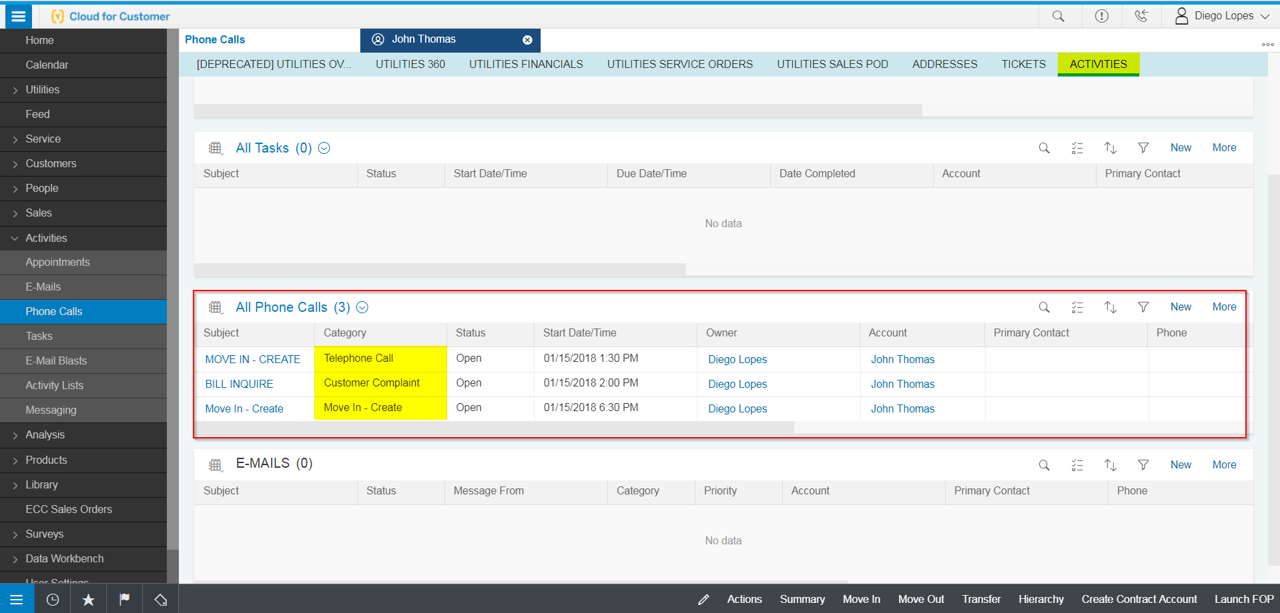
Figure 1 – Activities in Hybris C4C

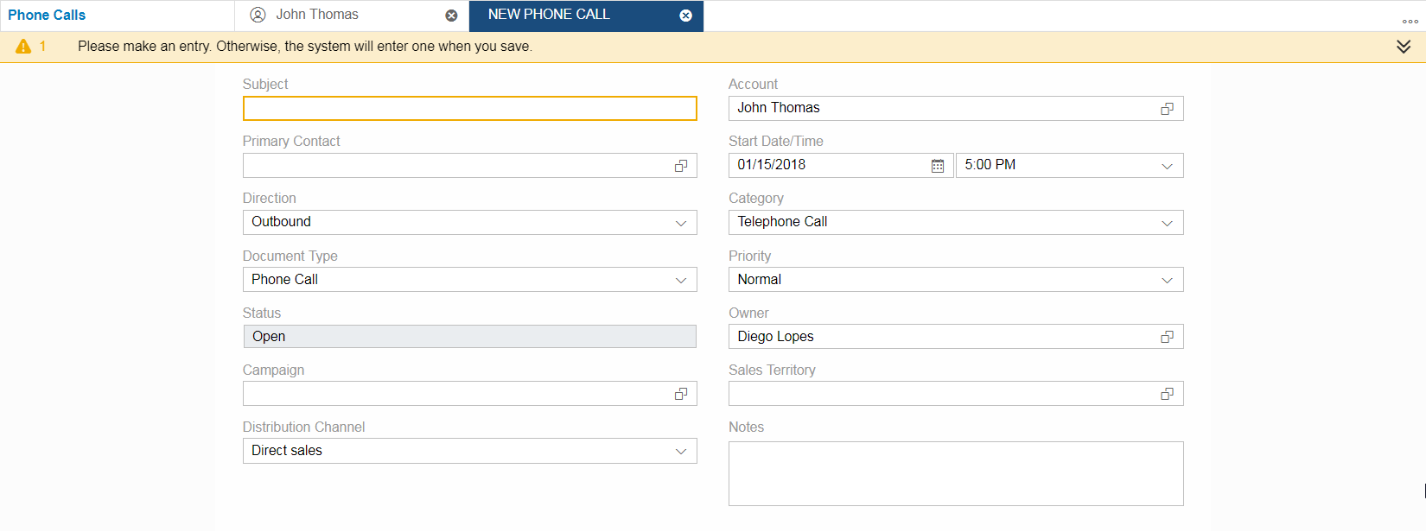
Figure 2 - Activity Fields

Activities Properties
An Activity is classified using the following characteristics: category, start date and time, owner (the user who created the record), territory ID, campaign ID, and the notes.
Category
In C4C Hybris Category is the only container to categorize an interaction with the customer, therefore it will merge Class and Action from the BP Contact. It will define the type of transaction between the business and the company and also the type of action carried out.
Direction
Type of action carried out for the business partner based on the class category.
Priority
Urgency level of the activity

BP Contact Properties
For back-office processes that are executed in S/4HANA, BP Contacts as shown in Figure 3 (the equivalent of an activity in Hybris C4C) will be created to identify the type of contact and method of contact with the Customer or system. BP contacts will be created using the following properties: Class, Action, Type, Direction, and Priority.
Class
Type of transaction between the business partner and the company. Examples of contact classes include dunning, billing, and marketing. The configured contact classes will be contained in the document CIM-CS-12 - BP Contact_Activities Categorization List.
Action
Type of action carried out for the business partner based on the class category. The configured actions will be contained in the document CIM-CS-12 - BP Contact_Activities Categorization List.
Type
Specifies how the business contact was initiated, for example, by letter, telephone, or via the Internet. The following types will be configured in S/4HANA:
- Phone
- Mail
- Email
- Web Chat
- Social Media
- SCE.COM
- Walk-In
- IVR
Direction
Type of action carried out for the business partner based on the class category. The following Directions will be configured in S/4HANA:
- Incoming
- Outgoing.
Priority
Urgency level of the BP Contact. The following Priorities will be configured in S/4HANA:
- Very Low
- Low, Average
- High
- Very High.

Hybris C4C will provide a view that will display all the BP Contacts from S/4HANA as per mention in section 2.4 General Assumptions.

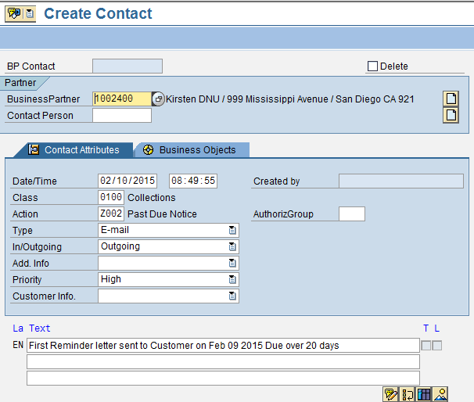
Figure 3 - BP Contact in S/4HANA

Activity Attachments
Activities allow the possibility of adding a local file, web link or a document from the library as an attachment to the activity as per displayed in Figure 4. Multiple files or links can be associated with each Activity.

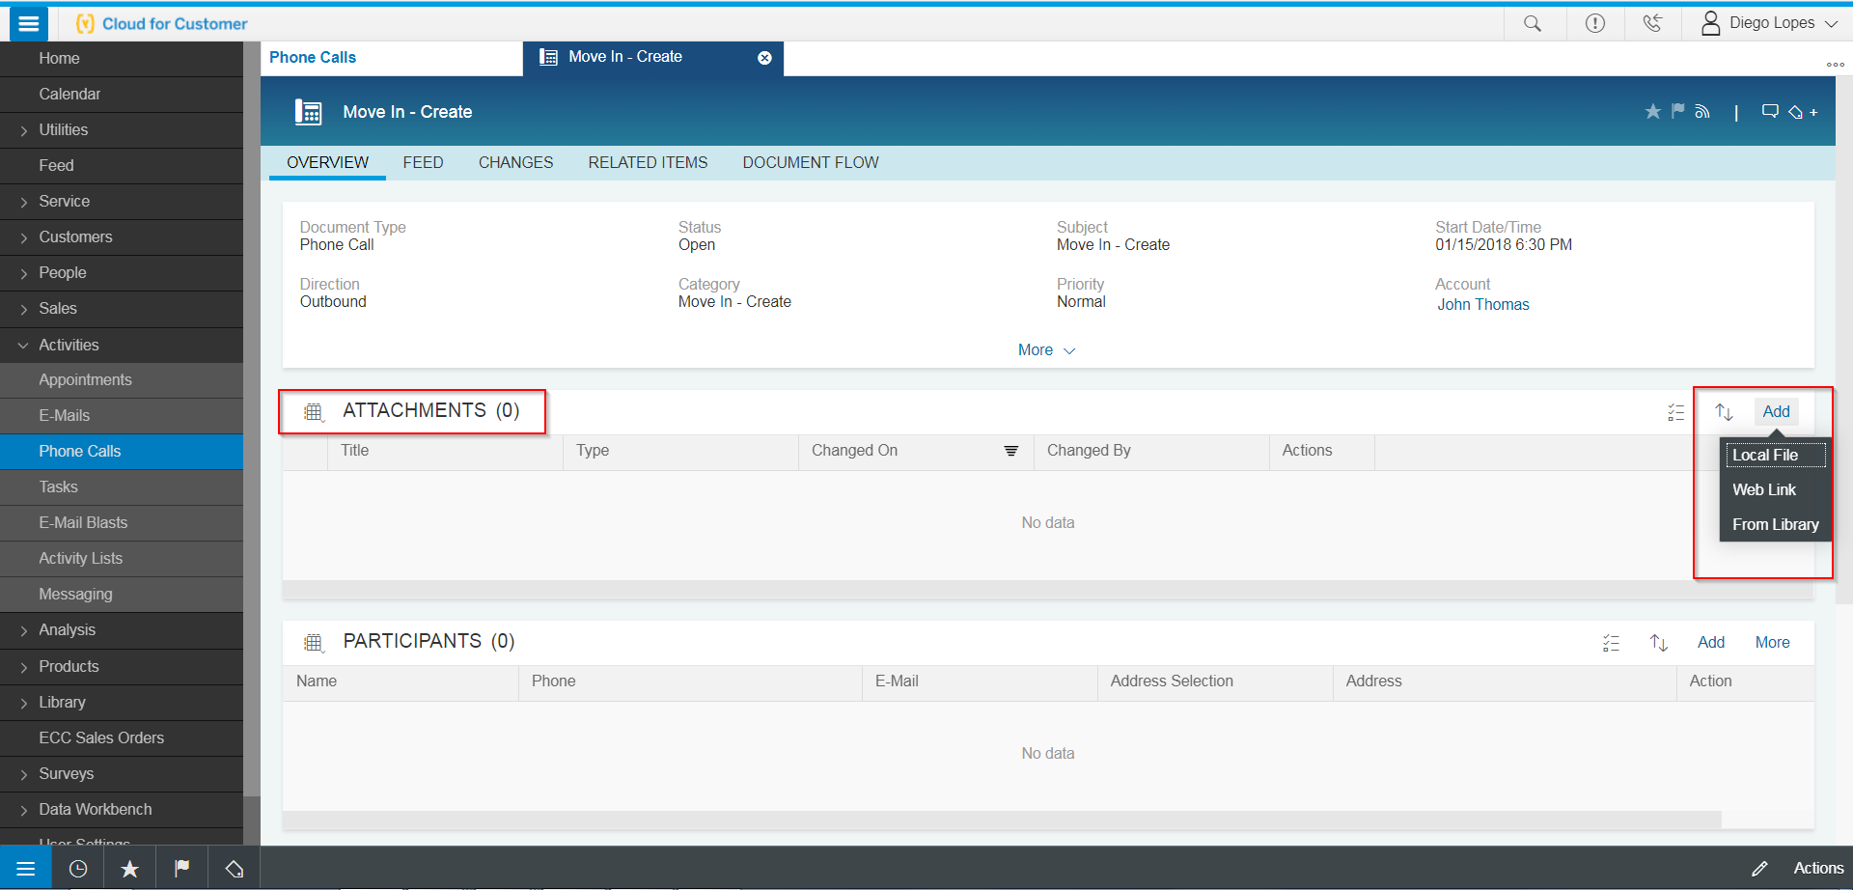
Figure 4 – Activity Attachments

Activity Search
Activities can be searched by navigating, e.g. to the Phone Calls view, as displayed in Figure5. This view is configurable and the sections can be added or removed as well the filters in which is possible to return the listed activities.
Hybris C4C standard proposed search view.
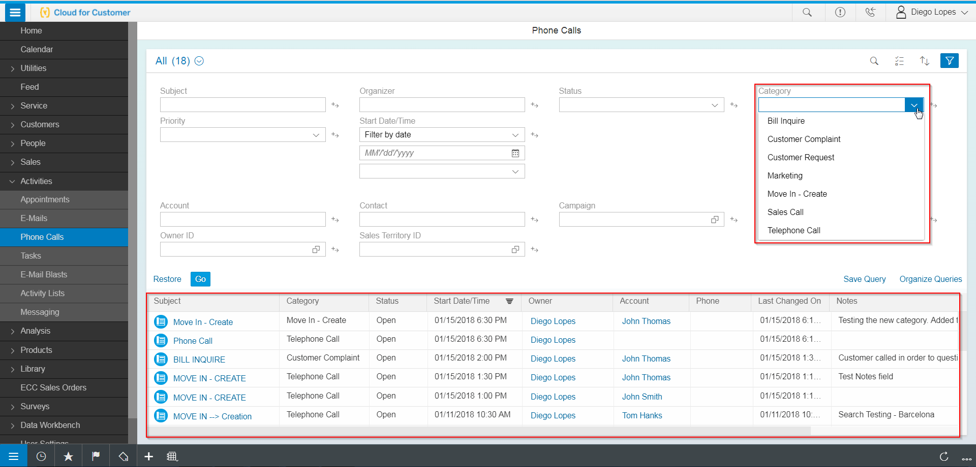
Figure 5 – Activity Global Search

Follow-up
Whenever a follow-up is required in order to give continuity to a certain Activity, the user may do so, by navigating to Related Items inside the Activity details. This section allows the user to create a follow-up for the following activities, for example, Appointment, Task, Phone Call, Service Ticket, etc.
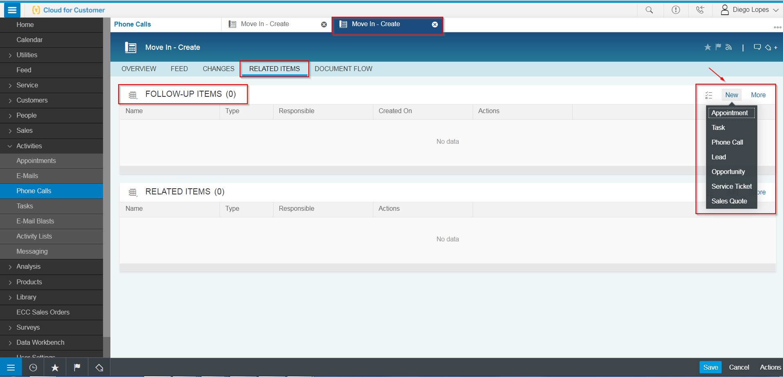
Figure 6 – Follow-up Items

Process / Performance Improvement
Greater visibility of all Activities for the Customer Activities can be searched by category, owner, and account.

Prerequisites and Inputs
A request to create or change Activity may originate via the following channels or systems:
- Technical Master Data
- Business Partner
- Contract Account
- Premise

General Assumptions
SAP is currently planning on adding a view that will allow displaying BP contacts from S/4HANA in Hybris C4C as of May 2018.

Business Process Hierarchy
This Business Process Hierarchy provides a listing of all scenarios/business processes, sub-processes, and SAP Transaction codes identified to support this process.
Level 1 | Level 2 | Level 3 | Level 4
Back Office, Data Migration, Automatic Contact Creation | BP Contact Process | Create Contact | BCT0
Back Office | BP Contact Process | Change Contact | BCT1
Back Office, Migration, Automatic Contact Creation, Hybris C4C | BP Contact Process | Display Contact | BCT2
Activity Creation | Activities Process | Display Activities | Activities
Activity Search | Activities Process | Display Phone Calls (Search) | Phone Calls

Process Flows
This BPD will cover the process involved in the creation of Activities via Hybris C4C. Each subsection where the process is detailed will have a process flow diagram for that process and a table detailing the steps that are taken within that process including processes handled outside of SAP.

Manual Creation
The below flow shows the manual creation of the Activity – one in which the user creates an Activity by clicking on the Activities facet after confirming the Customer.

Process Flow Diagram

Process Flow Steps

Step | Description of Step | Front Office | Role(s)
10 | START | N/A | N/A
20 | Front Office is opened. | Hybris C4C | Customer Interaction Management-Business Master Data
30 | Customer calls, Agent searches for Customer by name in Utilities Customer Search | Hybris C4C | Customer Interaction Management-Business Master Data
40 | Agent confirms the customer by selecting Customer ID from the results returned. | Hybris C4C | Customer Interaction Management-Business Master Data
50 | Agent navigates to the Activities tab. | Hybris C4C | Customer Interaction Management-Business Master Data
60 | Activities View opens | Hybris C4C | Customer Interaction Management-Business Master Data
70 | Agent clicks New in All Phone Calls section | Hybris C4C | Customer Interaction Management-Business Master Data
80 | Agent enters the Category to categorize the type of activity that was interacted with the Customer | Hybris C4C | Customer Interaction Management-Business Master Data
90 | Agent enters notes to give further details about the activity | Hybris C4C | Customer Interaction Management-Business Master Data
100 | Agent clicks on Save. | Hybris C4C | Customer Interaction Management-Business Master Data
110 | The Activity is successfully saved. | Hybris C4C | Customer Interaction Management-Business Master Data
120 | END

3rd Party and SCE Legacy System Integrations
3rd Party or SCE Legacy System Integration | Description of Integration and Required Change to 3rd Party or SCE Legacy System | Estimated Complexity of 3rd Party or SCE Legacy system change
IVR | Possible use of shared functionality
SCE.COM | SCE.COM is currently going through a modification in functionality
Open Text | New Integration
Bolt-on | New Integration
Marketing Solution

Data Elements

BP Contacts Data Elements
The following data elements will be used by the BP Contact.
Field | Type | Comments
Business Partner Number | Required | This is the BP number associated with the Contact
Contact Type | Required | Channel that was used for the interaction
Contact Class | Required | First level for Contact categorization
Contact Action | Required | Sub Level for Contact Categorization
Date | Optional | Creation date of the BP Contact
Time | Optional | Creation time of the BP Contact

    - Source Systems and Data Volumes
Identify the historical amount, volume, and Southern California Edison source systems for data objects supporting this process. The expected annual growth rate is [percent growth]%, for another [number of records] to be added to SAP per annum.

Cloud for Customer (C4C) Integration

Processes
Activity creation will be done through the majority of the existing processes.

C4C Views
Activities View

Activities
All Activities, this BPD will provide a full list of all the possible Categories.

Exception Management Requirements
This section outlines a high-level description of each BPEM Case or other user workflow items (such as “Tickets” used by Hybris C4C) used to route work requests between business areas. The companion document for this section which outlines the detail of each case is documented in APSE on the Exception Case Template General Document #8.
User Exception Scenario / Description | User Group | Initiated by | Work Distribution
N/A

Process Risks and Mitigation
N/A

Key Performance Indicators
The following have been identified as KPI’s at Southern California Edison, along with the means of measuring each KPI and the current measurement statistic for each KPI:
Measured KPI | Description | Measurement Method | Current Statistic
N/A

Key Metric Definition
The following have been identified as key metrics at Southern California Edison that require a business rule for calculation:
Key Metric | Description | Business Rule | Reference
N/A

Controls, Regulatory Rules, and Security
Requirement  ID (from RTM) | “As-Is” Control Requirement | “To Be” Risk Statement | “To-Be” Control Activity” | Control Automation (manual, IT dependent- manual, automated | Relevant technical identifier or RICEFW reference
N/A

Security Considerations

Role | Transaction Code (T-Code) | T-Code Description | Authorization Attributes | SOD Conflicts (Yes/No)  If SOD Conflicts Yes. Identify the 2 conflicting t-codes
N/A

Custom Program/Transaction Codes
Please identify any custom programs/transaction codes that need to be developed for RICEFW objects.
- Is the custom program executed in the batch mode or dialogue mode
- Is the custom program assigned to an authorization group
- What is the custom transaction code for the custom program
- Should there be an authorization check made against any field in the custom program/custom t-code and if so what is the custom/standard authorization object used(For example does it have to be restricted to residential vs commercial customer)
- Does the custom programs/custom t-codes have any critical or sensitive customer information that needs extra security
Custom Program | Authorization Grp | Custom T-code | Authorization Object used in the authorization check statement
N/A

Custom Table/Transaction Codes
Please identify any custom tables/transaction codes that need to be developed for RICEFW objects.
- Are there any customer sensitive/critical Z tables created
- What is the authorization group assigned to the table
- Is it just a maintenance or display only table
- What is the Z transaction code for the custom table
Custom Table | Authorization Grp Assigned | Custom T-code for the Table | Table Access (display/update)
N/A

Data Criticality and Cybersecurity Baseline Risks

Specify the Information this BP will process, receive or transmit; | List data elements from section 2.8 here, including volume.  Data element Description Volume Risk (high, medium, low)
Specify Access Classification /Special Handling or Regulatory Requirement | <Select all that apply>  ☐ PII - Personal Identifiable Information / Privacy Law  ☐ CEII - Critical Energy Infrastructure Information  ☐ FERC SOC (Standards of Conduct)  ☐ NERC CIP Confidential  ☐ Sarbanes-Oxley (SOX) financial reporting data  ☐ SCE utility data accessible by affiliate companies (CPUC)  ☐ PCI - Payment Card Industry Compliance  ☐ Customer Information Service Request (CISR, CISR-DRP)  ☐ Other _<Please Specify>_  ☐ Internal  ☐ Public
Please identify which business Group/Role will require access to the data and/or solution: | <Select all that apply>  ☐ SCE Customer, Res./Comm. Customer;  ☐ SCE OU, Business Function Organization Name:  ☐ Vendor  ☐ External business partner(s) & SaaS providers  ☐ External on-shore contractors  ☐ External off-shore contractors  ☐ SCE Affiliate Company Employees  ☐ SCE Employees, specify if they have Marketing Function responsibilities (e.g., ES&M)  ☐ SCE contract workers  ☐ Regulatory Agencies  ☐ Others _<Please Specify>_
How many of the SCE Customer, Employee, Vendors will use or affected by the Business Process? | 100; 100 – 1,000; …..
How much Information/data would be processed, received or transmitted by the Business Process? | 100; 100 – 1,000; …..
Number of business transactions on average?
Legacy System Module (SAP) the Business Process operated on? | SAP Module, Object name; SCE Enterprise System/Application name: 3rd party application integration;  System Module Operated By:  CSS ….. MSP  Outage Notification Dispatch Corporate System Engineering 3rd Party
Targeted System Module | SAP Module, Object name; SCE Enterprise System/Application name: 3rd party application integration;  System Module Operated By:
Risk Rating  Please see Appendix for guidance on risk ratings (Very Low, Low, Moderate, High, or Very High) based on business impact should a breach occur in any of the three security | Confidential Integration Availability  H, M, L H, M, L H, M, L
Additional Security Consideration: | Any Cybersecurity impact in addition to SAP system security:  - Internet Facing Web Application? Yes/No, Details:  - Internet Facing Application Programming Interface?  - 3rd party Federated Authentication & Authorization, Single Sign-On?  - Cloud Application (non-C4C)?

Technical Considerations

4.1 RICEF-W Assessment
All of the Forms, Reports, Interfaces, Conversion items, Extensions/Enhancements and Workflows (RICEF-W) that have been identified for this BPD are detailed in the tables below and will represent the totality of all RICEF-W items documented at the time of sign-off of this BPD. Any RICEF-W items that are confirmed via change control after this BPD receives final sign-off, will be managed within Southern California Edison’s APSE environment and not within this document.

Reports
Report Name & Description (List Requirements met by this Report) | Complexity | Reference ID
This will be a self-service report.
R-CIM-CS-12 - A&R COE Performance Analytics | Complex | APSE #817
R-CIM-CS-12 - Account Coordinator Activities Tracking Report | Complex | APSE #818
R-CIM-CS-12 - Account Manager Interactions Report | Complex | APSE #819
R-CIM-CS-12 - CC COE Performance Analytics | Complex | APSE #826
R-CIM-CS-12 - Chronology DB | Simple | APSE #827
R-CIM-CS-12 - Daily Diagnosis | Simple | APSE #834
R-CIM-CS-12 - eChannel (User Performance) | Simple | APSE #835
R-CIM-CS-12 - IDSM COE Performance Analytics | Complex | APSE #840
R-CIM-CS-12 - OCT Channel Mix Data and On-Going Reporting | Medium | APSE #842
R-CIM-CS-12 - Offline support work | Simple | APSE #843
R-CIM-CS-12 - Rate COE Performance Analytics | Complex | APSE #845
R-CIM-CS-12 - SCE.com Interactions Report | Complex | APSE #847
R-CIM-CS-12 - Tier 2 reporting | Simple | APSE #848
R-CIM-CS-12 - Weekly Detailed Reports with Additional Fields | Simple | APSE #852

Interfaces
Interface Name & Description (List Requirements met by this Interface) | Complexity | Reference ID
N/A

Conversion
Conversion Name & Description (List Requirements met by this Conversion) | Complexity | Reference ID
C-CIM-CS-12 - CONTACT | Medium | APSE #134

Extension/Enhancements
Extension Name & Description (List Requirements met by this Extension) | Complexity | Reference ID
E-CIM-CS-12 - IR creation | Medium | APSE #1171
E-CIM-CS-12 - Create IR from outbound and inbound comm | Medium | APSE #1172
E-CIM-CS-12 - IR needs to be confidential | Complex | APSE #1173
E-CIM-CS-12 - IR custom search | Complex | APSE #1174
E-CIM-CS-12 - Auto-populate Campaign ID | Complex | APSE #1175
E-CIM-CS-12 - IR custom view | Medium | APSE #1176
E-CIM-CS-12- Interaction Record | Medium | APSE #800

Forms
Form Name & Description (List Requirements met by this Form) | Complexity | Reference ID
N/A

Workflows
Workflow Name & Description (List Requirements met by this Workflow) | Complexity | Reference ID
N/A

IDEX Considerations
N/A

Production System Cut-over Considerations
N/A

4.4 Other Considerations
N/A

Change Management

5.1 Change Impacts
Change Element Short Description | Change Impact Category | Audience Group(s) | Impact | Business Effort
In SAP, once an Activity note is entered, the note cannot be updated/changed in the front end user interface once it has been submitted. A front-end user will need to add another note in the same Activity once the Activity has been submitted if changes need to be made. | Process | CS-CSOD-CCC All;  CS-CSOD-RSO All | Low | Low
The Back office user interface (UI) has the capability to overwrite the Activity notes. Users of Back office UI will need to be trained to not update the notes on the IR. They should add a separate note to the Activity which is similar to what they do today to retain the original note on the Activity. | Process; Decision Making | CS-CSOD-CCC All;  CS-CSOD-RSO-Credit;  CS-CSOD-RSO-BOM | Low | Low
All users will have a consolidated list of Activity types that can be used by multiple groups (e.g., CCC, RSO, BCD, Consumer Affairs etc.) so that there will be one comprehensive list for all Activities. Currently, CCC and BCD have their own disposition listing that is stored in the system that they use (e.g. CWO and Legacy CRM). Other organizations do not use Activities or dispositions. The Activities process and listing will be consolidated so that all users are using the same types. It can be used for reporting purposes. | Process; Benefit/Improvement | CS-CSOD-CCC All;  CS-CSOD-RSO All;  CS-CP&S-All;  CS-BCD-All | Medium | Medium
In SAP, front-line users will be able to view current and historical Activities at the BP level. They will see the last 4 Activities in the general screen and can view other Activities on a separate screen. There will be a consolidated view of the Activities per account. BCD currently searches Activities by type/subtypes in CRM. Users will need to be trained on where to locate Activities in SAP. | Process; Benefit/Improvement | CS-CSOD-CCC All;  CS-CP&S-All | Low | Low
In SAP, users will document the customer contact via an Activity. It is a comprehensive interaction history that can be used by all SCE users that interacts with the customer. It will also record contacts from sce.com as well as IVR. The status will automatically be coded as complete for each interaction with the ability to change the status. This provides a full view of the customer's touch points. Today an agent documents the contact in a disposition and through notes and it is only available to the CCC and IVR. This should enhance customer experience because agents will have access to all Activities at their fingertips. | Process;  Culture Shift; Benefit/ Improvement; Technology; Decision Making | CS-CSOD-CCC All;  CS-CSOD-RSO All;  CS-CP&S-All;  CS-BCD-All | Medium | Medium

Below is a description of each:
Change Element Short Description: Describes the ‘As-Is’ scenario and what is changing.
Change Impact Category: Determined by asking the questions below.
- Staffing Levels - Is the work effort increasing or decreasing (staffing levels), and how (e.g., task automation, new process/tasks)?
- Job Roles - Will the responsibilities, authority, or required skills for a job or job roles change? Will people be reporting to new leaders? Will managers’ responsibilities change?
- Compensation / Performance - Will the changes have such an impact on roles of an individual that merits a change in how they are compensated or how their performance will be evaluated? What behaviors are rewarded and recognized?
- Organization Structure - Is the ownership of the Process or Data changing (think departments, jobs, or roles, not individuals)?
- Decision Making - Will any of the changes impact how decisions are made, by or between, business units/departments? Who makes them, how they determine the criteria for making a change?
- Culture Shift - Will organizational value systems impact the way change happens or be impacted by the change? What are the underlying values of the organization that will directly influence the way change will be accepted and how much work will ultimately be required to ensure successful outcomes for the business?
- Location / Facilities - Will the change impact the physical location where the process is being implemented or require changes to the facilities to enable the process to be effective?
- Process - Any change to the current process (e.g. manual process becomes automatic, or vice versa)? Are there new processes being introduced or an old process being decommissioned? Is there a requirement to change an existing business rule or business policy? Will new business rule or policy need to be introduced and enforced or complied with?
- Regulatory/ Legal - Are there any legal/regulatory requirements that might be impacted
- Technology - Are other applications impacted (e.g., going away, becoming read-only), or are there new requirements (e.g., new SW / HW, new version)
- Benefit/Improvement - Will there be an improvement or benefit to any of the stakeholders because of this change. (Be sure to include any pain points that are being alleviated)
- Other - Are there emotional implications stemming from any of these changes (think of buy-in issues or fears)
Audience Group(s): These are the affected departments, divisions etc…
Impact: The following were used to determine the impact:

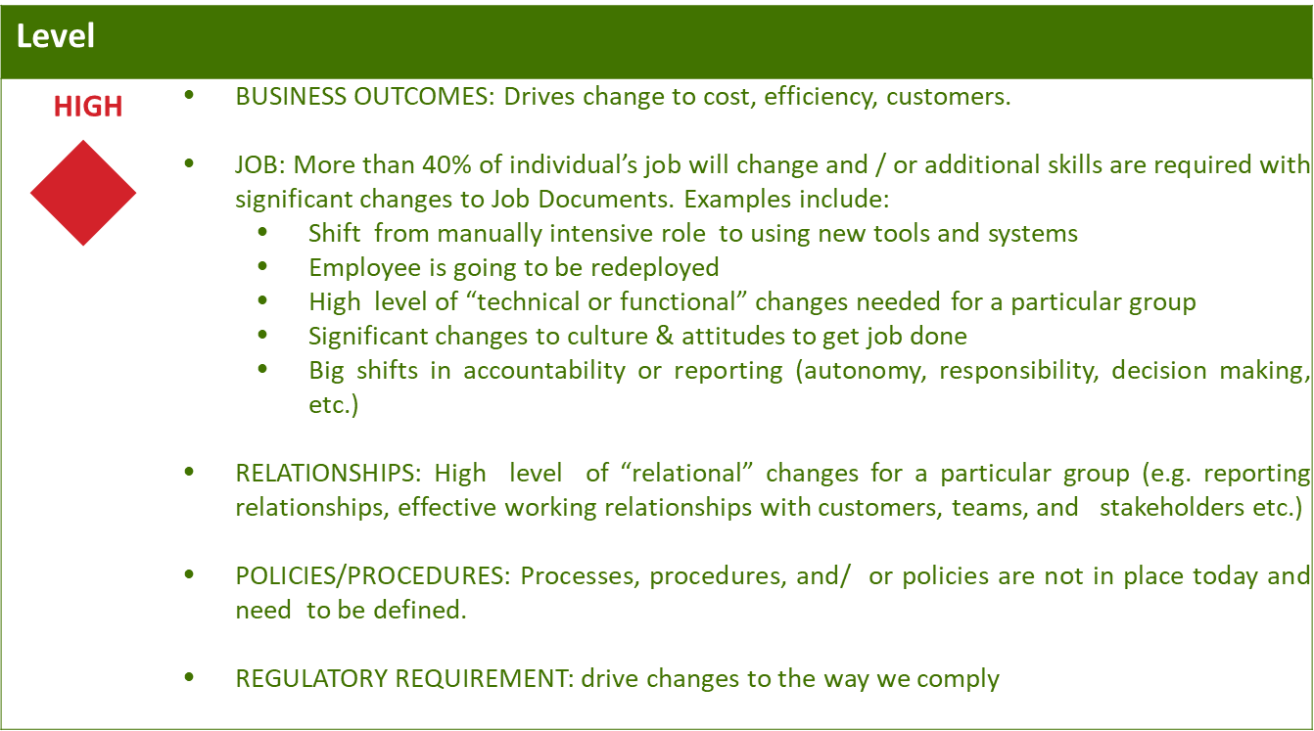
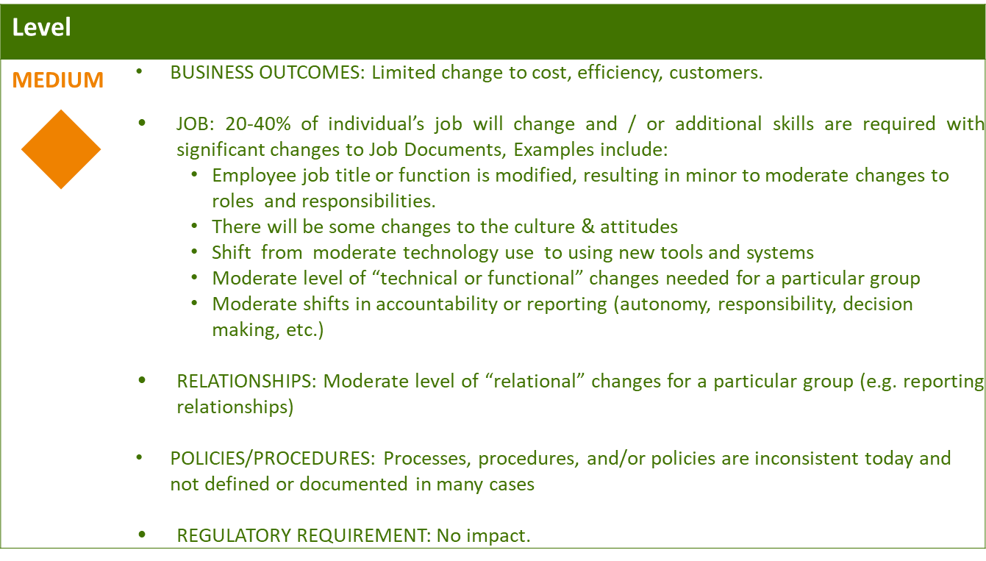
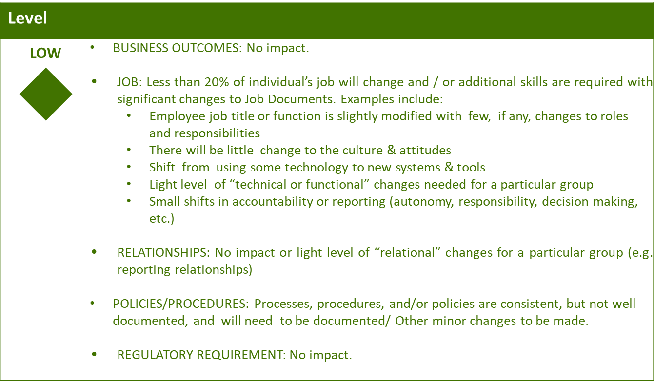

Business Effort: Initial assessment of the impact to the business High, Medium, Low

Requirements

Requirement # | APSE Requirement # | Requirement Description

